Figures

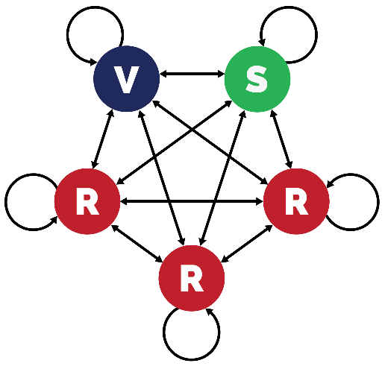

Figure 1. Contact structure for the 20-20-60 model. There are 5 segments, each comprising 20% of the total. V = vulnerable; S = shielders; R = remaining population. Transmission occurs within and between segments. Transmission rates within and between the three R segments are always homogenous, but may vary within and between segments of different types.

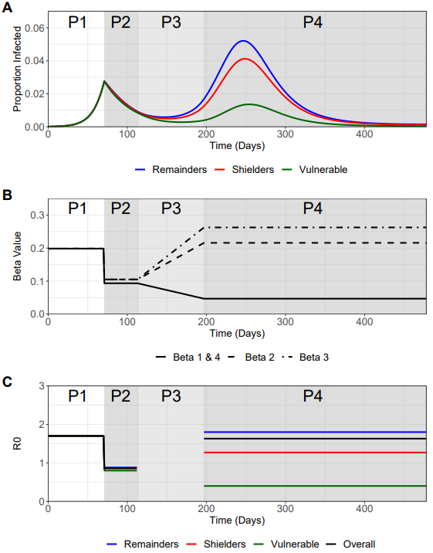

**Figure 2 – Trajectory plots for the vulnerable, shielders and remainder populations, with accompanying β and R0 plots**.

A) Trajectory plots of the proportion of infecteds in the vulnerable (green), shielders (red) and remainders subpopulations (blue), shading depicts the different phases of enhanced shielding intervention.

B) Values for the different β over the course of the simulation as they are implemented for the different intervention phases.

C) Values of the corresponding R0’s (colors) for the different subpopulations and the overall R0 (black) during the different intervention phases.

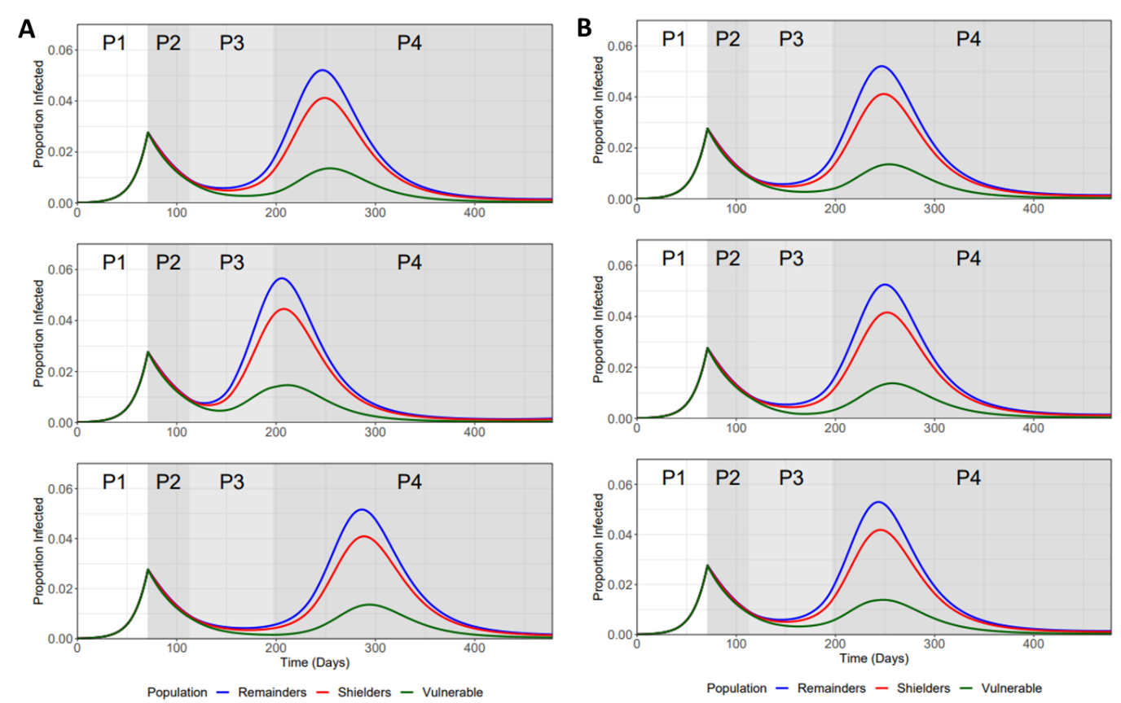

**Figure 3 – Sensitivity analysis for the length of phase 3 ramp-down (β1 & β4) and ramp-up (β2 & β3) periods.** Top plot for both A) and B) refers to baseline values.

A) TOP plot: 12 Weeks ramp-up (β3 & β4) and 12 Weeks ramp-down (β1 & β4), MIDDLE plot: 6 Weeks ramp-up and 12 Weeks ramp-down, BOTTOM plot: 18 Weeks ramp-up and 12 Weeks ramp-down.

B) TOP plot: 12 Weeks ramp-up (β3 & β4) and 12 Weeks ramp-down (β1 & β4), MIDDLE plot: 12 Weeks ramp-up and 6 Weeks ramp-down, BOTTOM plot: 12 Weeks ramp-up and 18 Weeks ramp-down.

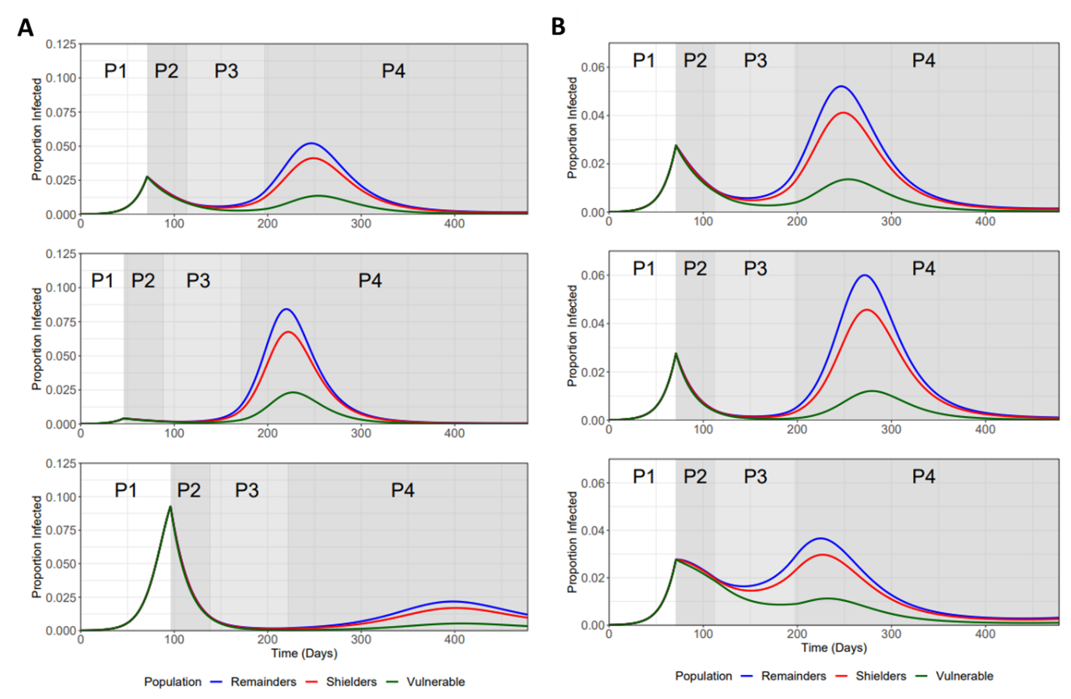

**Figure 4 - Sensitivity Analysis for varying the trigger Point and phase 2 β.** Top plot for both A) and B) refers to baseline values.

A) Trajectory plots for the subpopulations for varying trigger points (starting day of lock down; I(t) refers to the fraction of vulnerable infected on trigger day): TOP plot: day 71 (I(t) = 0.0277), MIDDLE plot: day 46 (I(t) = 0.0042), and BOTTOM plot: day 96 (I(t) = 0.0.093).

B) Trajectory plots for the subpopulations for variation in phase 2 beta values – variation is referred to in terms of the R0 values used to calculate β1 & β4 (first number) and β2 & β3 (second number) phase 2 values: TOP Plot: 0.8/0.9, MIDDLE Plot: 0.6/0.7, and BOTTOM Plot: 1.0/1.1.

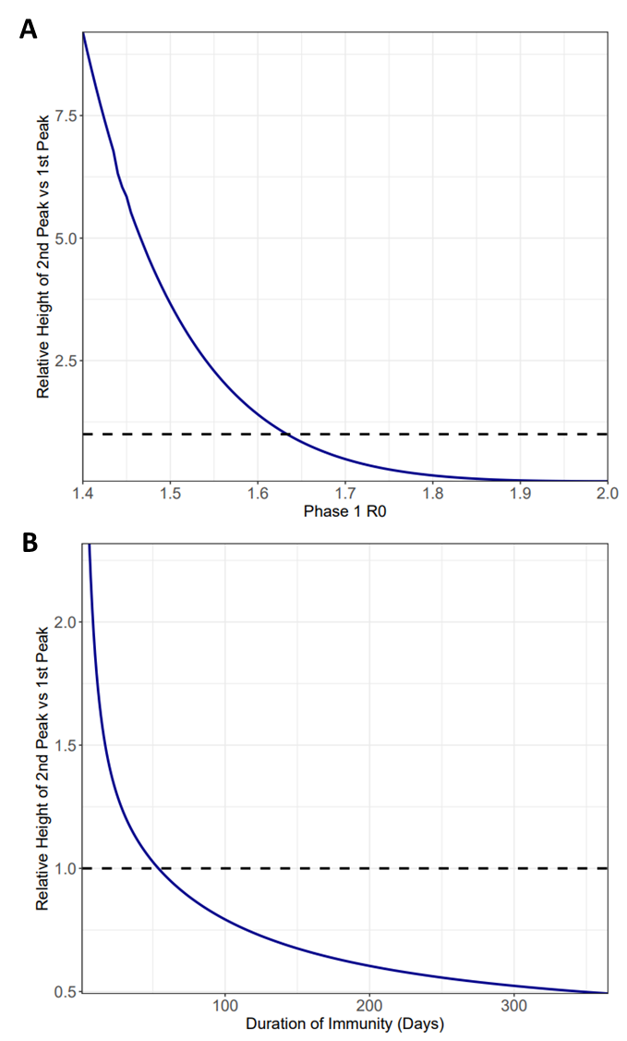

**Figure 5 – Relationship between Phase 1 Beta and Zeta values (expressed in 1/zeta) on the relative height of 2nd peak vs 1st peak for the vulnerable population.** Dotted line represents the point at which the first IV peak equals the second IV peak.

**A)** Phase1 R0 is varied between 1.4 – 2.0 (with baseline being 1.7). R0 values are used to calculate the β in each model run.

B) The duration of immunity (1/ζ) is varied between 0 and 365 days (baseline).

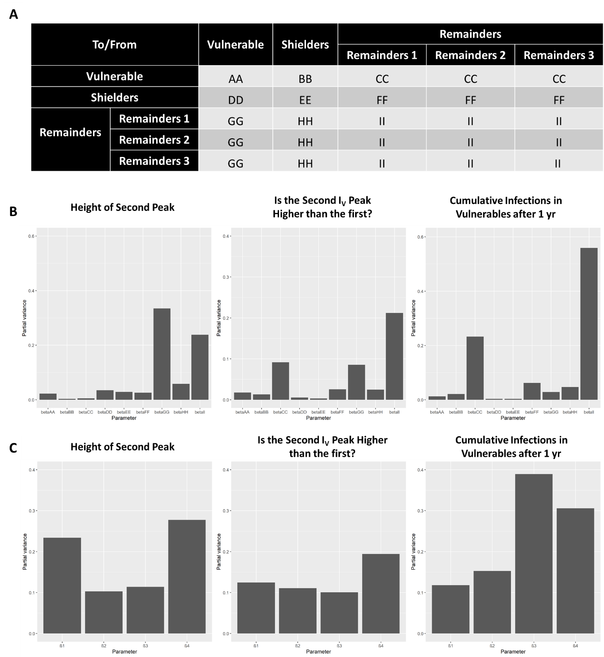

**Figure 6. Results of a global sensitivity (FAST) analysis on three key outcome measures with regards the proportion of the vulnerable population that become infected (Iv)**: 1) the height of the second peak of Iv; 2) whether the second peak of Iv is higher than the first peak and 3) cumulative Iv one year after the start of the lockdown. The bars show the partial variance of the individual model parameters. Higher bars indicate greater sensitivity of the model to that parameter. See Supplementary Methods for details of the sensitivity analysis and parameter ranges used.

A) Description of explored β value “blocks” for the sensitivity analysis. β1, β2, β3 and β4were broken down further to more rigorously assess the sensitivity of the system to these values. Lettering denotes the explored β in the FAST analysis.

B) Sensitivity of the model outcome measures to the β’s specified in A).

C) Sensitivity of the model outcome measures to β1, β2, β3 and β4.

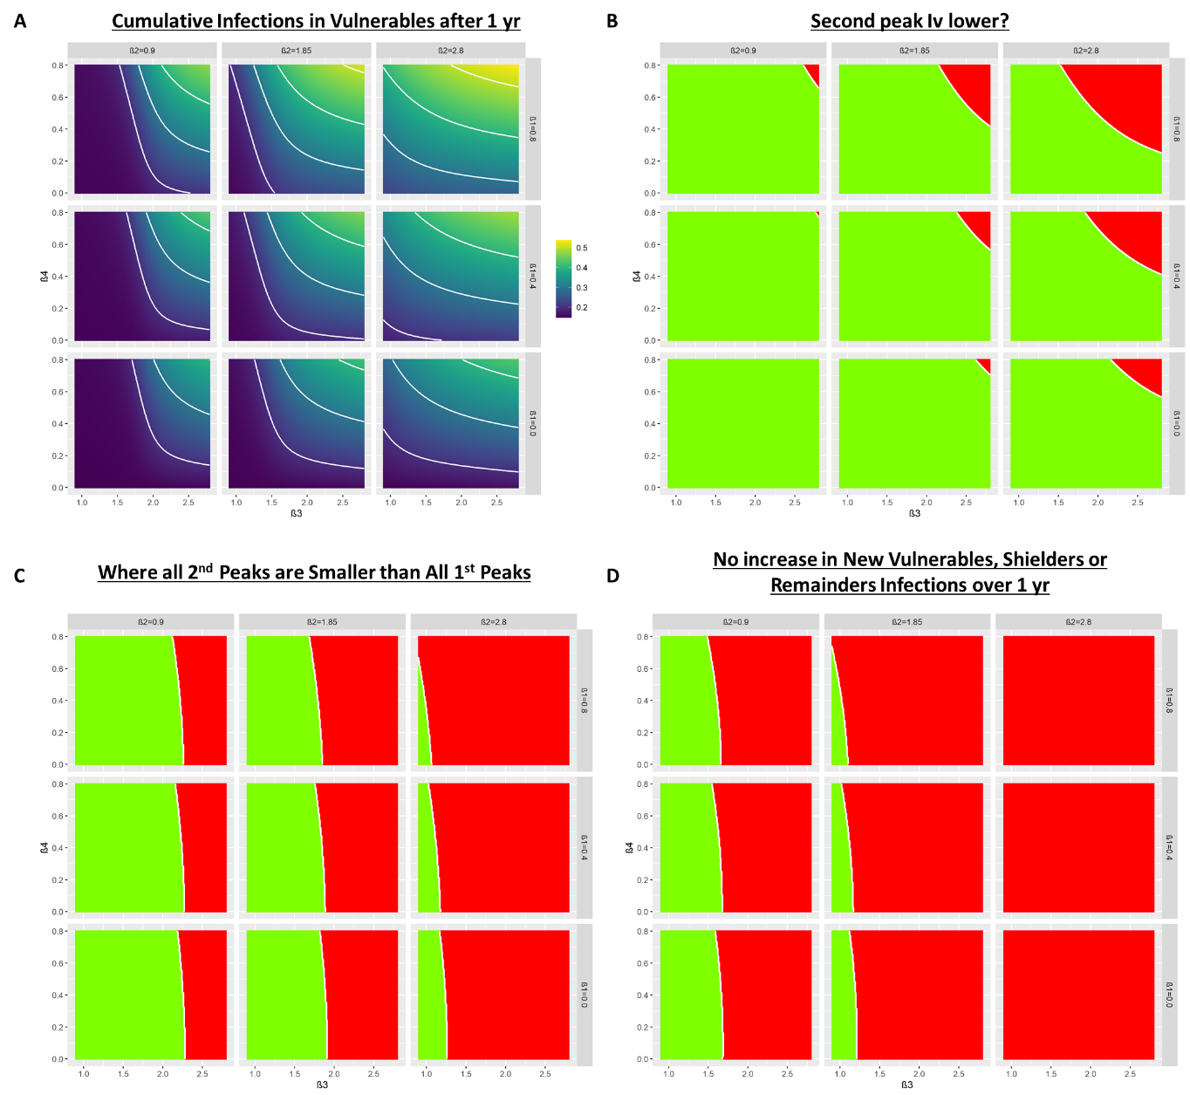

**Figure 7. Heat maps showing the trade-off between relaxation (left to right on horizontal axis) and increasing protection (top to bottom on vertical axis)**.

A) Heat maps describing the cumulative infected vulnerable fraction (Iv) one year after the start of lockdown for different combinations of β3 and β4 for different values of β1 (rows) and β2 (columns).

B) As A) but for whether the second peak of Iv is lower (green) or higher (red) than the first peak.

C) As (B) but all 2nd peaks (Iv, Ih, Ir) smaller than 1st peaks (green).

D) As (B) but dI­/dt is negative or zero for at least 1 year after the start of lockdown for all I-compartments.

Tables

Table 1. Comparison of the estimated distribution of COVID-19 burden for the 60-20-20 and the 90-5-5 scenarios

|  |  |  |  |  |  |
| --- | --- | --- | --- | --- | --- |
| Population structure (v/s/r) | Sub-population | Proportion of population | Relative risk of severe disease | Cumulative incidence* | Proportion of severe disease burden* |
| 20-20-60  model  (Baseline) | Vulnerable | 0.20 | 16 | 0.316 | 0.634 |
| Shielders and Remainders | 0.80 | 1 | 0.730 | 0.366 |
| 2-2-96  model | Vulnerable | 0.02 | 64 | 0.163 | 0.368 |
| Shielders and Remainders | 0.98 | 1 | 0.944 | 0.632 |
| 8-8-84 | Vulnerable | 0.08 |  |  |  |
| Shielders and Remainders | 0.84 |  |  |  |
| 14-14-72 | Vulnerable | 0.14 |  |  |  |
| Shielders and Remainders | 0.72 |  |  |  |

*Over one year from day 71

**SUPPLEMENTARY INFORMATION**

**METHODS SUPPLEMENT**

**Description of Model Structure**

A frequency-dependent SIRS-type model was used to explore the effect of enhanced shielding with three sub-populations being modelled:

* Vulnerable Population (NV) - Those who have risk factors that place them at elevated risk of developing severe disease if infected with COVID-19 and so would remain shielded whilst the rest of the population is gradually released from lockdown.
* Shielders Population (NS) - Those who have contact with the vulnerable population and include carers, certain care workers and healthcare workers. It is expected that they would also continue some shielding whilst the rest of the population is released from lockdown.
* Remainders Population (NR) - The majority of the population – those that are not vulnerable or shielders.

For the baseline scenario, a population structure of 20% vulnerable, 20% shielders and 60% remainders was used **(Table M1)**. A total infectious fraction of 0.0001 (split equally across the population) was used as the initial conditions to seed infection. Model parameters were chosen to best describe the transmission dynamics of COVID-19 in the UK using current assumptions (as of publication) regarding the values of key epidemiological parameters **(Table M2)**.

The SIRS model assumes that the number of new infections in a sub-population is a function of the fraction of the sub-population that is susceptible (SX), the fraction of the sub-population that is infectious (IX) and the rate of infectious transmission between the two sub-populations (βX). Infectious individuals subsequently recover at a rate γ that equates to an 8.6 day infectious period. Recovered individuals are assumed to lose immunity and return to being susceptible over 365 days (**Eqn 1.1**). All β were calculated as a function of the reproduction number and gamma (γ) (**eqn 1.2**). Gamma itself is calculated as the reciprocal of the generation time, which is a function of the baseline basic reproduction number (R0) and the baseline doubling time (T2) (**eqn 1.3**)

**Table M1** – SIRS Model Compartments and Initial Conditions for Baseline Scenario

|  |  |  |
| --- | --- | --- |
| Compartment | Description | Initial Conditions |
| SV | Susceptible fraction of the population who are vulnerable | 0.19998 |
| SS | Susceptible fraction of the population who are shielders | 0.19998 |
| SR | Susceptible fraction of the remainder population | 0.19994 |
| IV | Infectious fraction of the population who are vulnerable | 0.00002 |
| IS | Infectious fraction of the population who are shielders | 0.00002 |
| IR | Infectious fraction of the remainder population | 0.00006 |
| RV | Recovered fraction of the population who are vulnerable | 0 |
| RS | Recovered fraction of the population who are shielders | 0 |
| RR | Recovered fraction of the remainder population | 0 |

**Table M2** – Parameter Descriptions and Values

|  |  |  |
| --- | --- | --- |
| Parameters | Description | Value |
| R0 | Baseline basic reproduction number | 2.8 |
| T2 | Baseline doubling time | 3.3 days |
| βx | Per capita rate of infectious transmission | Varies (see Table 3) |
| γ | Per capita rate of recovery | 0.1167 day-1 |
| ζ | Per capita rate of immunity loss | 0.0027 day-1 |

Eqn1.1

Eqn1.2

Eqn1.3

**WAIFW Matrix and Modelling Transmission**

A “who acquires infection from whom” (WAIFW) matrix was created to describe transmission between the three sub-populations (**Tabl**e **M3**). For the baseline scenario of 20/20/60, the remainder population was split into three subgroups, to explicitly model differences in contact/transmission between the remainder sub-population and the vulnerable/shielders.

Segregating the remainders into sub-groups allowed for greater flexibility in the frequency-dependent framework, enabling variation to be modelled in the transmission rates between different sub-populations, whilst, critically, maintaining a globally balanced and fixed R0 value throughout the model. However, the three remainder sub-groups are functionally identical, with homogenous mixing in the remainder sub-population assumed to occur and with β values being identical within/between the remainder sub-groups.

Four β values were used to parameterise the model: β1 describes transmission within/between the vulnerable and shielder subpopulations, β2 describes transmission between shielders and the remainder subpopulations, β3 describes transmission within the remainder subpopulations and β4 transmission between remainder and vulnerable subpopulations (Table M3).

**Table M3** – Generic WAIFW matrix used for the model and the transmission parameters β, which defines transmission between subpopulations

|  |  |  |  |  |  |  |
| --- | --- | --- | --- | --- | --- | --- |
| To/From | | Vulnerable | Shielders | Remainders | | |
| **Remainders 1** | **Remainders 2** | **Remainders 3** |
| Vulnerable | | β1 | β1 | β4 | β4 | β4 |
| Shielders | | β1 | β1 | β2 | β2 | β2 |
| Remainders | **Remainders 1** | β4 | β2 | β3 | β3 | β3 |
| **Remainders 2** | β4 | β2 | β3 | β3 | β3 |
| **Remainders 3** | β4 | β2 | β3 | β3 | β3 |

The WAIFW matrix structure allows for similar levels of transmission within the vulnerable and between the protective shielders sub-population (β1). Shielders themselves can subsequently contact the remainder sub-population at a different level (β2), with the remainder population having greater levels of contact with one other (β3). Transmission between the vulnerable and remainder sub-populations was assumed to be much lower than with other sub-populations (β4).

**Modelling Enhanced Shielding**

To model the effect of an enhanced shielding strategy on COVID-19 transmission, four intervention “phases” were considered. These phases describe social distancing measures which aim to control a COVID-19 epidemic. Interventions were modelled as alterations in the reproduction number (R) values (translated into β values) (eqn 1.2), representing changes in infectious pressure resulting from these control measures.

In the context of an enhanced shielding strategy, the intervention phases were assumed to impact the R values (and subsequently the β values) differently within/between each sub-population, to reflect the loosening or tightening of social distancing measures throughout the progression of the outbreak (**Table M4**). The transition from phase 1 to phase 2 represents the hard lockdown implemented on the 24th March 2020, phase 3 represents a progressive release (for the remainder subpopulation) or tightening (for the vulnerable subpopulation) of restrictions applied over a 12-week period. Phase 4 represents the end point of the gradual transition of phase 3. The model simulations start on day 0 and lockdown is implemented on a selected “trigger day" which corresponds to where the proportion of total recovered individuals (Rtot) is 0.06 seven days after the trigger day. The R values that are modelled in the baseline scenario are also shown in **table M4** and were used to calculate the β values used in each phase.

**Table M4** – Description of Phased Enhanced Shielding Strategy

|  |  |  |  |  |  |  |
| --- | --- | --- | --- | --- | --- | --- |
| Phases | Description of Intervention Phase | Duration | R0 used to calculate β* | | | |
| **β1** | **β2** | **β3** | **β4** |
| Phase 1 | Represents the “business as usual” approach that was operating pre-lockdown. We assume a pre-lockdown R of 1.7 – reflecting pre-existing reductions to transmission from a baseline R0 = 2.8 (spontaneous social distancing etc). | Up until Rtot(t+7) = 0.06  (day 71) | 1.7 | 1.7 | 1.7 | 1.7 |
| Phase 2 | Represents the nationwide lockdown that was applied approximately equally to all subpopulations. We assume that pre-existing shielding in the vulnerables has resulted in reductions to R relative to the shielders and remainders (R = 0.8/0.9). | 6 Weeks | 0.8 | 0.9 | 0.9 | 0.8 |
| Phase 3 | Represents a progressive change in restrictions – a progressive release of regulations to the remainder subpopulation and a progressive tightening of restrictions applied to the vulnerable subpopulation. R values change linearly from phase 2 to phase 4 over the course of 12 weeks. | 12 Weeks | Linear Change to Phase 4 | | | |
| Phase 4 | Represents the long-term application of the released restrictions to the remainder subpopulation and long-term enhanced shielding of vulnerable subpopulations. We assume that R is reduced further in the vulnerables by ½ as part of the enhanced shielding strategy. Based on a “back-to-normal” R0 = 2.8, we model a partial return back-to-normal for the shielders (even greater return for the remainder). We assume a central value between lockdown and back to normal for the shielders (0.9 < R < 2.8), and a central value between pre-lockdown and back-to-normal for the remainder sub-population (1.7 < R < 2.8). | Until End of simulation  (1 Year after lockdown ends – 478 days from start of simulation) | 0.4 | 1.85 | 2.25 | 0.4 |

* All R0 values used are for illustrative purposes and are best guess for the effect of interventions and SDMs based on expert opinion.



**Sensitivity Analysis**

To test the susceptibility of the core results to key parameters and uncertainty in the model formulation, several sensitivity analyses were conducted. These explored:

1. Varying phase 1 R0 values from the baseline value of 1.7 (explored range of 1.4 – 2.0)
2. Varying phase 2 R0 values from the baseline value of 0.8/0.9 (explored range of 0.6/0.7 – 1.0/1.1)
3. Varying the trigger day from day 71 (R(t+7) = 0.06) to day 46 and 96.
4. Varying the duration of the phase 3 ramp-down (β1 & β3) and ramp-up (β1 & β3) from baseline of 12 weeks (explored range of 6 – 18 weeks)
5. Assessing the sensitivity of the main model output to individual beta values in the WAIFW matrix

**Description of FAST Analysis**

We determine which model parameters have most influence on the outcome values (height of second peak fraction of the vulnerable population that are infectious (Iv) , whether the second peak of Iv is higher than the first peak and the cumulative fraction of Iv one year after the start of lockdown) by computing the total sensitivity index *D*Ti using the extension of Fourier amplitude sensitivity test (FAST) as described in Saltelli *et al.* [ref Saltelli].

The extended FAST method is a variance-based, global sensitivity analysis technique that has been largely used for studying complex agricultural, ecological and chemical systems (see [ref Makowski, ref Neumann] for examples). Independently of any assumption about the model structure (such as linearity, monotonicity and additivity of the relationship between input factors and model output), the extended FAST method quantifies the sensitivity of the model output with respect to variations in each input parameter by means of spectral analysis.

It provides measures of the amount of variance of the prevalence that arise from variations of a given parameter in what is called a total sensitivity index, *D*Ti. It therefore captures the overall effect of parameter variations on the chosen outcome values (i.e. including first- and higher-order interactions between model parameters). For example, a value of *D*Ti = 0.10 indicates that 10% of the total observed variation of the prevalence is explained by the parameter under consideration. The sensitivity analysis was carried out using R [ref R (version 3.6.3)]. For the sensitivity analysis, we used a parameter range of -22% to +22% of the baseline value for all parameters under investigation.

**Software used**

SIRS model implemented in R and C++ independently (code available at <https://github.com/bvbunnik/COVID-19-enhanced-shielding.git>). Package “desolve” was used in R to implement model structure and analysis. Package “ggplot2” was used for all output plotting.

**References**

* Saltelli A, Tarantola S, Chan KPS. 1999A quantitative model-independent method for global sensitivity analysis of model output. Technometrics 41, 39–56. (doi:10.2307/1270993)
* Makowski D, Naud C, Jeuffroy M-H, Barbottin A, Monod H. 2006Global sensitivity analysis for calculating the contribution of genetic parameters to the variance of crop model prediction. Reliability Eng. Syst. Safety 91, 1142–1147. (doi:10.1016/j.ress.2005.11.015)
* Neumann MB, Gujer W, von Gunten U. 2009Global sensitivity analysis for model-based prediction of oxidative micropollutant transformation during drinking water treatment. Water Res. 43, 997–1004. (doi:10.1016/j.watres.2008.11.049)
* R Core Team (2020). R: A language and environment for statistical computing. R Foundation for Statistical Computing, Vienna, Austria. URL:https://www.R-project.org/.

SUPPLEMENTARY FIGURES

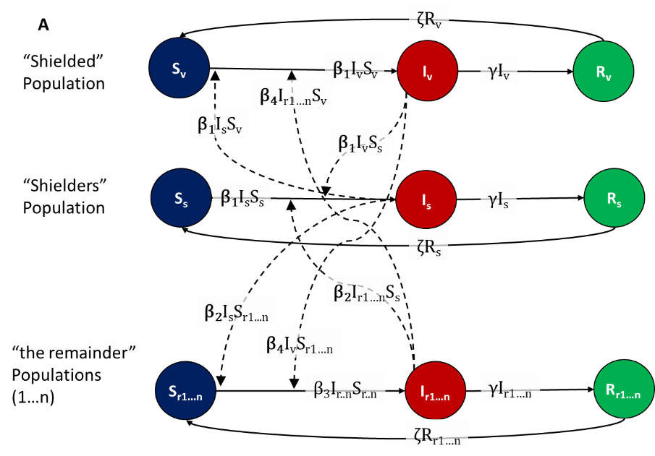

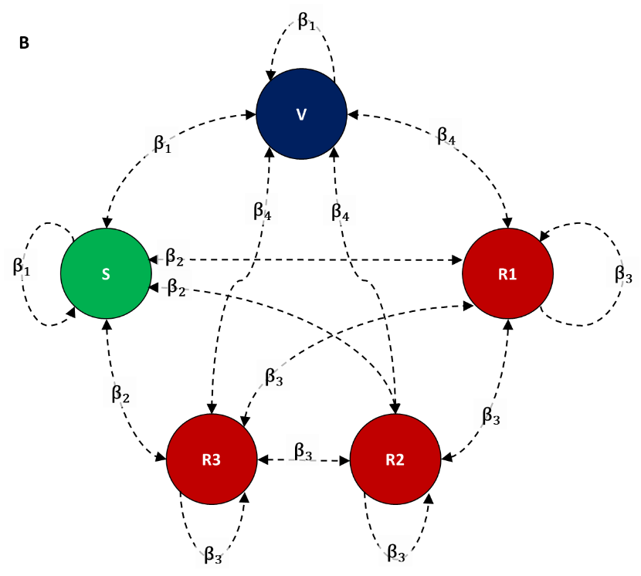

**Figure S1** - The SIRS model structure (A) defined by Susceptible, Infectious and Remainder compartments and (B) the 20-20-20-20-20 network structure with five equal sized populations: vulnerable (V), shielders (S) and three remainder populations (R1, R2 and R3). This illustrates the baseline with five equal sized populations, but can be extended to n equal sized populations by increasing the number of remainder subpopulations. We define four values of the rate of transmission (β) with β1 defining the rate of transmission within and between the vulnerable and shielders; β2 defines transmission between shielders and remainders; β3 defines transmission between the remainder populations and β4 defines transmission between remainder and vulnerable populations. People in the Infectious compartments recover at rate γ and people in the recovered compartments lose immunity at rate ζ.

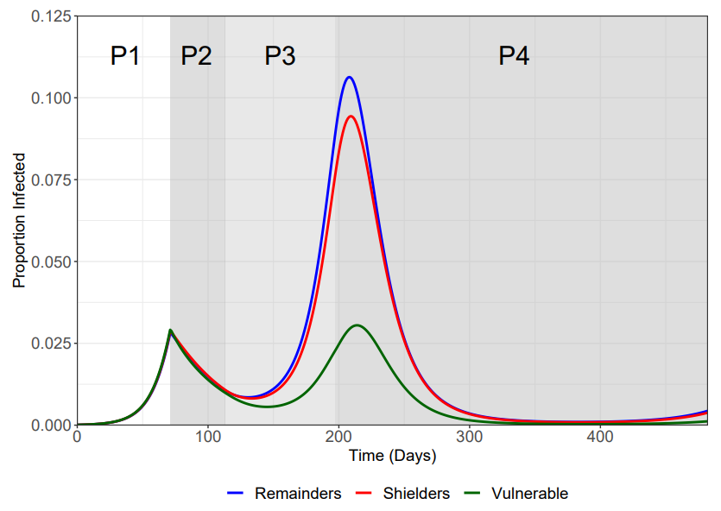

Figure S2. As Figure 2A for the 2-2-96 model.

SUPPLEMENTARY TABLES

Table S1. COVID-19 Shielding in the UK. A) Definition of vulnerable population [ref]. B) Shielding advice [ref].

**A**

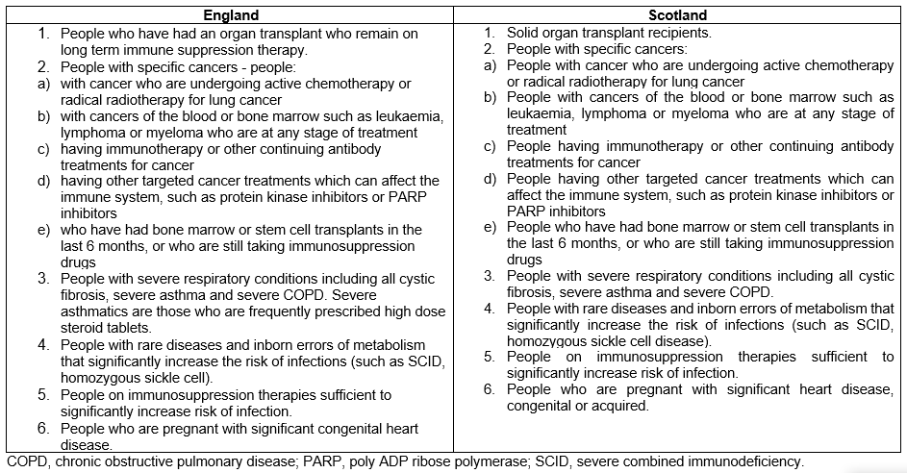

**B**

